This article phases about the impact of agile development model in Japanese software companies .It suggests that the software process is not explicit but embedded in various techniques such as CPI (Continuous Process Improvement) and TQC (Total Quality Control) in Japan. This article proposes the ASP (Agile Software Process) model based on the experiences in the distributed concurrent development, lessons learned in Japanese software factories and various concepts in hardware production process.

The ASP does not simply mean rapid application development. Rather, it emphasizes rapid and flexible adaptation to changes of the process, product and environment. Therefore, ASP is not a single technique but a total technology based on a coherent concept. The ASP model can be characterized as follows:

1. Incremental and Evolutionary Process
2. Modular and Lean Process
3. Time-Based Process

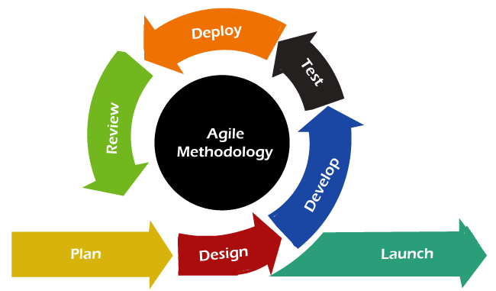To implement the ASP, they modularize software processes and products so that large-scale software can be developed as a collection of small units with a narrow range of productivity variation. Distributed development brought about another significant impact on the software process and management, and challenged us to re-think the way we do software development. The ASP assumes global distributed development where even a single person in a remote place can participate. Therefore, the ASP does not imply any specific physical office configuration but is a virtual software factory over the Internet.

To integrate a variety of software process techniques into workable ASP process, they have developed the following design principles:

1. Public Private Processes: Encapsulation of Private Process
2. Modular Process
3. Concurrent and Cyclic Enaction with Fixed Cycle- Time
4. Major and Minor Enhancement
5. Alternative Release Cycles
6. Fixed Process Speed and Workloads

An integrated software engineering environment is indispensable to implement and operate the ASP system. The environment has to provide a balanced support for process and product management. The article also explores the experiences of teams that have successfully adopted Agile. Aoyama describes how Agile has helped teams deliver high-quality software faster, improve customer satisfaction, and increase team morale. He emphasizes the importance of continuous improvement and learning in Agile, as well as the need for strong leadership and support from management.

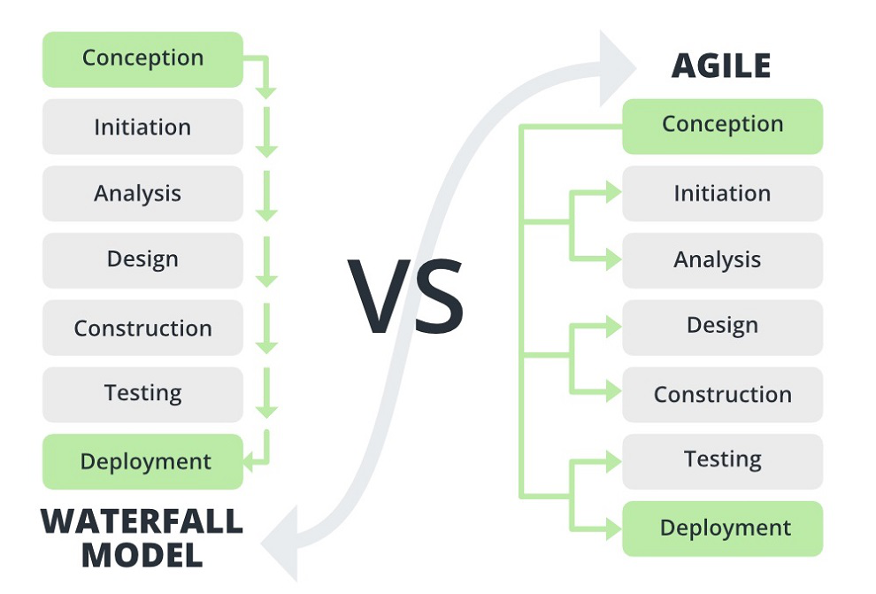Overall, the article provides valuable insights into the agile methodology and its impact on software development projects. It highlights the benefits of Agile, as well as the challenges and best practices for successful implementation. The ASP provided various benefits including shortening the development cycle-time by 75% from one year to three months. However, we realized that the ultimate goal of the ASP is to change the way we do software development. Unlike conventional process model based on the big-bang- delivery model and volume-base management, the ASP is based on an evolution model and on time-based management. Compared to other models it is more flexible and feedback oriented.